Co-Chair  Vernon Sykes, Representative  34th House District | 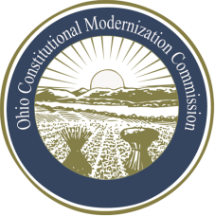 | Co-Chair  William G. Batchelder, Speaker  69th House District
Ohio Constitutional Modernization Commission

Public Education and Information Standing Committee Agenda

• Call to Order
• Roll Call
• Introduction of Members
• Scope of this Committee's Work
• Disseminating Information to the Public Regarding the Commission and its Operation
• Commission Web Site
• Social Media
• Document Similar to Florida's "Citizen's Guide to Proposing Changes"
• Commission Newsletter
• Resources for Teachers
• Media Strategy
• Discussion of Other Ways to Disseminate Information to the Public
• Seeking Input from the Public
• Ways to Seek Input from the People of Ohio
• Ways to Seek Input from Statewide Elected Leaders
• Ways to Seek Input from Organizations and Individuals that are Stakeholders in

• Constitutional Issues
• Seeking Input from Other Commission Members on This Committee's Work
• Adjourn

